Isotopomers and Isotopologues Using InChI
Ehren Bucholtz
University of Health Sciences and Pharmacy in St. Louis
ehren.bucholtz@uhsp.edu
This worksheet explores the concepts of isotopomers and isotopologues suitable for upper division chemistry students. The document provides learning objectives of the activity, success criteria as a way to let students know what they are expected to do on a test or quiz, and a section on prerequisite knowledge that students are expected to bring from other coursework.
The worksheet is written with the intention that students would complete this as an in-class exercise. There are multiple models that students are asked questions about to generate understanding. Finally, there is a “homework” section for additional practice outside of class.

Isotopomers and Isotopologues
Learning Objectives:
- Isotopomers and isotopologues are analogous molecules that differ by isotope composition and/or position within a molecule. Isotopomers have known isotopic position, while isotopologues have unknown isotopic position with a molecule.
- Determine which analytical tools can be used to identify isotopologues and isotopomers.
- The International Chemical Identifier (InChI) can be used to store isotopomer information for retrieval in a chemical database.
- A nonstandard InChI layer can be used when the of isotopic positions are unknown.

Success Criteria:
- Given a molecule, draw an isotopomer and an isotopolog
- Explain how mass spectral data can identify isotopologues, but NMR is typically necessary to identify isotopomers.
- Use the InChI isotopic /i layer to identify specific isotopomers and the nonstandard /a layer for the identification of isotopologues.

Prerequisite Knowledge:
- From General Chemistry: An isotope is a variant of a chemical element that has the same number of protons but a different number of neutrons in its nucleus, resulting in different atomic masses.
- From organic chemistry: Constitutional isomers, also known as structural isomers, are compounds with the same molecular formula but different connectivity, or atomic organization.
- From organic chemistry: Mass spectrometry is an analytical technique used to measure the mass-to-charge ratio of ions. It is widely employed to identify the composition of a sample by generating a mass spectrum, which displays the masses of the various components within the sample. The process involves ionizing chemical compounds to generate charged molecules or molecule fragments, which are then separated based on their mass-to-charge ratios.
- From organic chemistry: Nuclear Magnetic Resonance (NMR) spectroscopy is an analytical technique used to determine the structure, dynamics, reaction state, and chemical environment of molecules. It relies on the magnetic resonance properties of certain atomic nuclei. When placed in a strong magnetic field, nuclei of certain isotopes (such as ¹H, ¹³C, and ³¹P) resonate at characteristic frequencies when exposed to radiofrequency radiation. This resonance is influenced by the local chemical environment, making NMR spectroscopy a powerful tool for elucidating molecular structure.
Model 1: Isotopologues
Monoisotopic mass is a type of molecular mass used in mass spectrometry to calculate the exact mass of an ion or molecule. It's calculated by adding the accurate masses of the most abundant naturally occurring stable isotope of each atom in the molecule. For most organic molecules, this means adding the masses of the lightest naturally occurring isotopes.
Isotopologues are molecules differing only in their isotopic composition. Two isotopologues are the same chemical species, but with at least one atom containing a different number of neutrons. Isotopologues have differing molecular masses. The term isotopologue is derived from ‘isotope’ and ‘homologue’.
Table 1: Isotopologues of Methanol
Structure
Monoisotopic Mass (rounded amu) | 32 | 33 | 34 | 35

Critical Thinking Questions:
- Looking at each of the structures in Table 1 how can you tell they are isotopologues of the same molecule?

All structures have equivalent connectivity, but each has at least one atom with a different number of neutrons.

- Using the data in Table 1, identify the most abundant mass (in rounded amu) for each of the following elements:
Element | Hydrogen | Carbon | Oxygen
Most abundant mass | 1 | 12 | 16

- Carbon has three naturally occurring isotopes: carbon-12 (¹²C), carbon-13 (¹³C), and carbon-14 (¹⁴C). ¹²C and ¹³C are stable isotopes of carbon, while ¹⁴C undergoes radioactive decay. ¹⁴C is often used in radiolabeling drugs, because of the ability to produce molecules with almost identical chemical properties that can generate measurable radioactivity. Draw two different radiolabeled isotopologues of ethanol.

- Draw two different isotopologues of ethanol that have atomic masses of ~49 amu.
Ethanol has a monoisotopic mass of 46(H=1, C=12, O=16). 49 AMU requires a +3 to the mass. This can be achieved with three deuterium atoms, a carbon 13 with two deuterium atoms, a carbon 14 with one deuterium, one oxygen 18 with two deuterium atoms or one oxygen 18 with one carbon 13.

Model 2: Isotopomers
Isotopomers are defined as molecules having the same number of each isotopic atom, but differing in their positions. Isotopomers have the same molecular mass. The term isotopomer is a portmanteau of ‘isotope’ and ‘isomer’.
Table 2: Isotopomers of 1-butanol
Isotopomer Set A | Isotopomer Set B

Critical Thinking Questions:
- Looking at each of the structures in Set A in Table 2 how can you tell they are isotopomers of the same molecule?
All molecules in set A have the same connectivity and have one ¹³C found in different positions in the molecule.

- Looking at each of the structures in Set B in Table 2 how can you tell they are isotopomers of the same molecule?
All molecules in set B have the same connectivity and have two ²H found in different positions in the molecule.

- What is the relationship between molecules in Set A and Set B?
They are isotopologues as they are molecules differing only in their isotopic composition. Two isotopologues are the same chemical species, but with at least one atom containing a different number of neutrons.
- The average atomic mass of bromine is 80, with relative abundance of ⁷⁹Br and ⁸¹Br of about 50% each.
  - Draw two structural isomers of molecules that have the molecular formula C₃H₆Br₂. Add atomic masses as appropriate.

  - Draw 2 isotopologue structures of molecules (with respect to bromine) that have molecular formula C₃H₆Br₂. Add atomic masses as appropriate.

Note molecules 2 and 4 have the same mass, and connectivity, so they are actually isotopomers of the same isotopologue.
  - Draw 2 isotopomeric structures of molecules that have molecular formula C₃H₆Br₂. One isotopic atom should be a ²H, one should be ¹³C, and one should be ⁷⁹Br. Have the bromine on a terminal carbon to limit the possibilities.
Given that the ²H can be on 3 different carbons, and the 13C can be on three different carbons, and the bromine can only be on a terminal, that means there are 9 possible solutions.
Model 3: ¹H-NMR spectra of Ethanol with ²H Isotopes
The following simulated spectra explore isotopologues of ethanol. Integration is indicated next to each signal in the spectra.
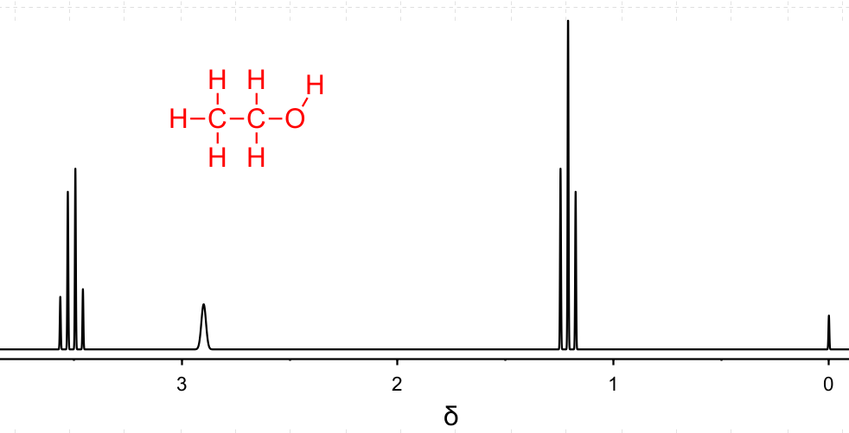
2H
1H
3H
Figure 1: ¹H NMR Spectrum of CH₃CH₂OH
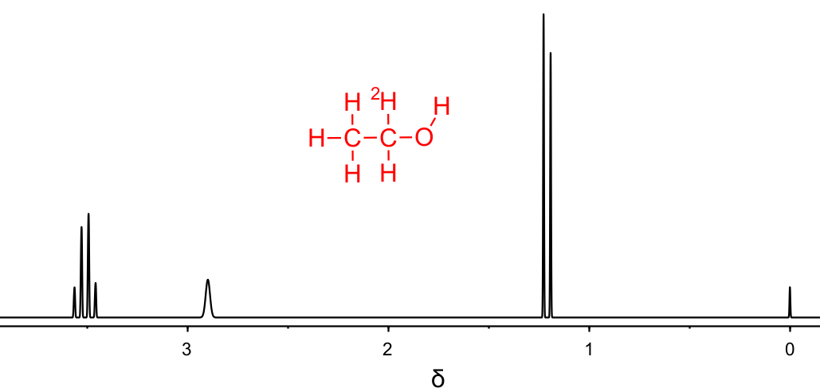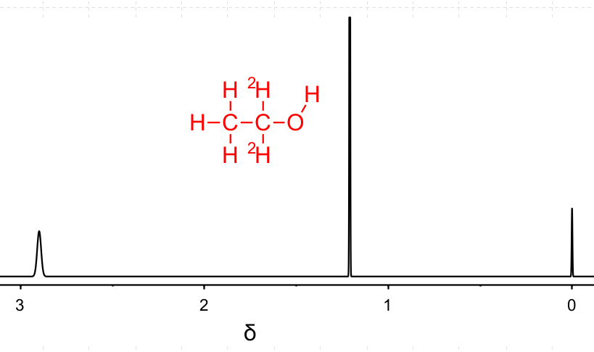
1H
3H
1H
1H
3H
Figure 2: Simulated ¹H NMR Spectrum ofCH₃CH²H₂OH Figure 3:Simulated ¹H NMR Spectrum ofCH₃C²H₂OH

Critical Thinking Questions:
- Explain the splitting patterns shown in Figure 1 of CH₃CH₂OH. Be sure to identify which protons (¹H) are associated with each chemical shift δ and why they are split that way.
At δ1.2, a triplet is found which means it represents the terminal CH₃ protons. It is more upfield as it is farther away from the electronegative oxygen.
At δ2.9, a broad singlet is found which means it represents the alcohol OH. These are rarely seen in actual spectra due to proton exchange with the solvent.
At δ3.4, a quartet is found which means it represents the CH₂ protons. It is more downfield as it is adjacent to the electronegative oxygen. The quartet follows a n+1 splitting as it has 3 proton neighbors of the terminal CH₃.

- Why is there a signal at δ 3.4 ppm in Figure 2, but none found in Figure 3?
Deuterium, an isotope of hydrogen, does not appear in proton (¹H) NMR spectra and does not cause splitting of neighboring proton signals. This explains why we see a quartet integrating for 1 proton in Figure 2, and no signal in Figure 3.

- What accounts for the difference in splitting of the peaks found at δ 1.2 ppm in Figures 1-3?
The splitting changes because the number of protons changes in each structure. In Figure 1, protons of the CH₂ provide n+1 splitting pattern and the result is a triplet. When one of the protons is exchanged for a deuterium as shown in Figure 2, the splitting pattern changes to a doublet as there is just one nearest neighbor proton splitting the signal. Finally in Figure 3 both protons are exchanged with deuterium and the n+1 splitting pattern results in a singlet.

- How might isotopologues be identified via NMR?
NMR spectroscopy can be used to elucidate isotopologue structures by taking advantage of the distinct magnetic properties of different isotopes of the same element. For example, substituting hydrogen with deuterium in a molecule changes the NMR-active nuclei from ¹H to ²H, which resonates at a different frequency.

Model 4: Mass Spectrometry of Ethanol with ¹³C Isotopes
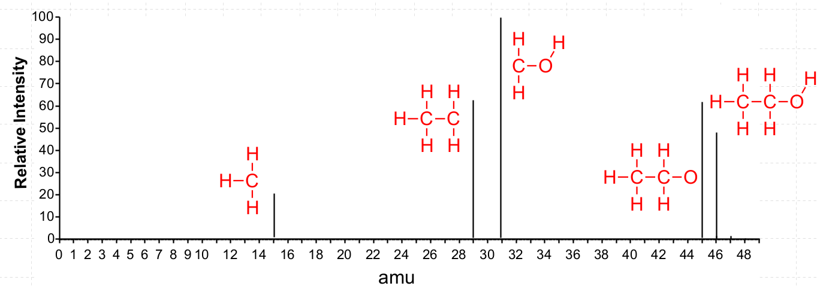
Figure 4:Simulated Mass Spectrum of CH₃CH₂OH with potential fragmentation patterns.
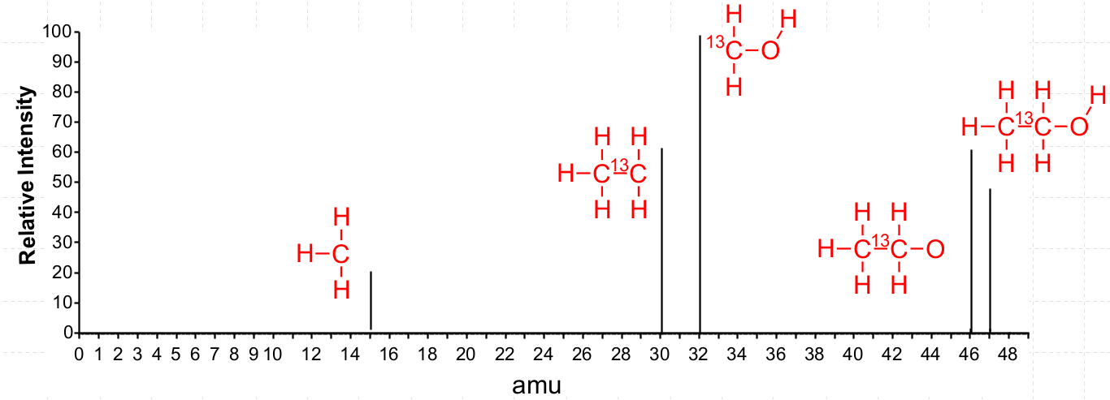
Figure 5: Simulated Mass Spectrum of CH₃¹³CH₂OH with potential fragmentation patterns.
Critical Thinking Questions:
- Explain how the shown m/z peaks in Figure 4 correspond to the structures adjacent to the peaks.
Adding the atomic masses of the indicated atoms in the fragments will result in matching the shown peak. For example, the molecular ion peak of 46 is from carbon (2x12), Hydrogen (6x1), and oxygen (1x16) for a total of 46 amu. CH₃ at the other end of the spectrum is from carbon (1x12) plus hydrogen (3x1) for a total of 15 amu.

- Why do some of the peaks in Figure 5 change compared to Figure 4, but not all?
Not all carbons have been changed to ¹³C isotopes.

- How do the shown m/z peaks in Figure 5 indicate the ¹³C atom is on carbon 1 and not on carbon 2?
The ¹³C isotope is only found on one of the carbons resulting in changes in fragments that only contain that isotope.

- How would the spectrum change if the molecule was ¹³CH₃CH₂OH?
The m/z peak at 15 would now be 16 as it is from a carbon (1x13) plus three hydrogen (3x1) for a total of 15 amu. The molecular ion peak would be the same, and all the other peaks would decrease by 1 AMU.

- How can mass spectrometry be used to differentiate between isotopologues?
Mass spectrometry can be used to elucidate isotopologue structures by analyzing the mass-to-charge ratios of ions derived from molecules that have different isotopic compositions. When a sample containing isotopologues is ionized and analyzed in a mass spectrometer, each isotopologue generates a unique peak in the mass spectrum corresponding to its specific mass. By examining these peaks, scientists can identify the presence and relative abundance of different isotopes. Additionally, the fragmentation patterns of these isotopologues can provide detailed structural information. The presence of specific isotopic labels, such as ²H or ¹³C, allows for tracking particular atoms through the fragmentation process, enabling the elucidation of the molecular structure and the positions of isotopic substitutions. This detailed mass analysis helps in understanding the structural differences between isotopologues and provides insights into their chemical and physical properties.
Model 5: InChI Line Notation
The International Chemical Identifier (InChI) is a standardized textual representation of chemical substances, developed by the International Union of Pure and Applied Chemistry (IUPAC). It provides a unique, machine-readable code that encapsulates the structural information of a molecule. Traditional names and graphical representations of molecules can be ambiguous and inconsistent, leading to difficulties in data sharing and retrieval. InChI addresses these challenges by offering a uniform and precise way to represent chemical structures, facilitating efficient data integration, searchability, and interoperability among different databases and software tools. This standardization is crucial for advancing research, enabling accurate communication, and ensuring reliable access to chemical information across disciplines.

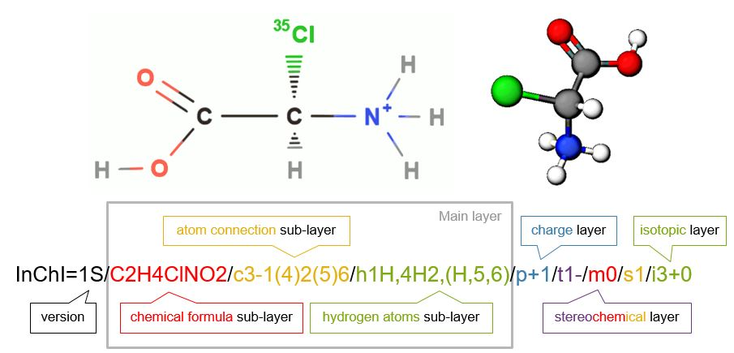
Figure 6: The main layers for a standard InChI of [(R)-carboxy(chloro)methyl]azanium, the protonated form of 2-(35Cl)chloro-R-glycine . Note each layer or sublayer is separated by a forward slash [/].
Critical Thinking Questions:
- What information is provided in the main layer of an InChI string?
Chemical formula, atom connections, hydrogen atoms

- What is the overall charge in the molecule shown in Figure 6 and how is this indicated in the InChI?
There is a positive charge on nitrogen yielding a +1 overall charge. The charge layer is indicated with p+1.

- Is the molecule shown in Figure 6 chiral? If so, how is this indicated in the InChI?
Yes, as indicated by a stereogenic carbon with 4 different substituents. It is indicated with the stereochemical layer.

- Are there any isotopes shown in the molecule? If so, how is this indicated in the InChI?
The chlorine in the molecule is ³⁵Cl. It is shown in the isotopic layer.

Information: The InChI Trust maintains a web demonstration of the InChI code. It is located at https://iupac-inchi.github.io/InChI-Web-Demo/ Open a web browser and go to the link.

- In the InChI Web Demo, draw ethanol and obtain the InChI.
  - What is the InChI for ethanol?
InChI=1S/C2H6O/c1-2-3/h3H,2H2,1H3

  - Which layers are included in the InChI?
Main which includes the chemical formula, atom connections, and hydrogen atoms.

  - Which layers are excluded from this InChI? Why?
Layers excluded are charge, stereochemistry and isotope layers. Ethanol is neutral, achiral, and contains no isotopes as drawn.

- Explore the following InChI strings for isotopomers of ethanol:
Structure | InChI
 | InChI=1S/C2H6O/c1-2-3/h3H,2H2,1H3/i2D
 | InChI=1S/C2H6O/c1-2-3/h3H,2H2,1H3/i1D
 | InChI=1S/C2H6O/c1-2-3/h3H,2H2,1H3/i3D

  - What information is consistent in the InChI?
The main layer is unchanged.

  - What part has changed in the InChI? How is the location of the deuterium atom indicated?
The isotope layer has changed, indicating a deuterium atom is present. The location is given by an atom number.
  - Does the numbering of the location of the deuterium atom follow standard IUPAC nomenclature numbering rules?
No, the 1 position would be the carbon connected to the oxygen, but in this case the other carbon is position 1.
- Using the InChI web demo, draw the following isotopic form of ethanol:
  - What is the InChI of this molecule?
InChI=1S/C2H6O/c1-2-3/h3H,2H2,1H3/i1+1,3D

  - How is the ¹³C isotope identified in the InChI?
Position 1has a +1 indicating it has an extra neutron at that position.

  - Predict the InChI for the following isotopologue of ethanol based on answers to parts a. and b.
InChI=1S/C2H6O/c1-2-3/h3H,2H2,1H3/i1D, 2+1

  - Check to see if your predicted InChI is correct by drawing the molecule in the web demo.
Students may predict “/i2+1,1D”, not recognizing that the /i layer goes from atom 1 to x.

  - How would your InChI isotope layer change if you had ¹⁴C instead of ¹³C in the previous example?
The isotope layer would read /i1D, 2+2
Information: To represent isotopologues, a new ambiguous isotope localization “/a” layer specification has been added to the InChI. The isotopologue layer starts with “/a” followed by an encoded description within parentheses.

- How are isotopologues and isotopomers distinquished in a standard InChI?
The /i isotope layer identifies any isotopes and their positions. The /a ambiguous layer identifies isotopic composition, but not specific positions.

Homework
Consider the 13C NMR spectra of ethanol:
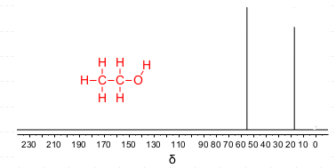
- Explain why there are two different peaks found in the spectrum and why one is more downfield than the other.
Ethanol exists as two isotopomers: one in which the ¹³C atom is on the methyl group (¹³CH₃CH₂OH) and one isotopomer in which the ¹³C atom is on the methylene (CH₃¹³CH₂OH). This results in 2 different peaks in the 13C NMR spectrum due to proximity to the electronegative/deshielding oxygen.
- Is the spectrum the result of isotopomers or isotopologues? Explain.
The spectrum is the result of isotopomers. The is a 1% chance of having 13C at either the 1 or 2 position in the molecule. Each isotopomer will show up in the spectrum but will have different intensities.
- What is the relationship between ¹³CH₃CH₂OH and ¹³CH₃¹³CH₂OH?
They are isotopologues. They have different atomic masses due to differing number of isotopes found in the molecule.
- Using the InChI Web Demo, generate InChI for the three ¹³C isotopologues of ethanol.
Molecule | InChI
¹³CH₃CH₂OH | InChI=1S/C2H6O/c1-2-3/h3H,2H2,1H3/i1+1
CH₃¹³CH₂OH | InChI=1S/C2H6O/c1-2-3/h3H,2H2,1H3/i2+1
¹³CH₃¹³CH₂OH | InChI=1S/C2H6O/c1-2-3/h3H,2H2,1H3/i1+1,2+1

