Isotopomers and Isotopologues
Learning Objectives:
- Isotopomers and isotopologues are analogous molecules that differ by isotope composition and/or position within a molecule. Isotopomers have known isotopic position, while isotopologues have unknown isotopic position with a molecule.
- Determine which analytical tools can be used to identify isotopologues and isotopomers.
- The International Chemical Identifier (InChI) can be used to store isotopomer information for retrieval in a chemical database.
- A nonstandard InChI layer can be used when the isotopic positions are unknown.

Success Criteria:
- Given a molecule, draw an isotopomer and an isotopolog
- Explain how mass spectral data can identify isotopologues, but NMR is typically necessary to identify isotopomers.
- Use the InChI isotopic /i layer to identify specific isotopomers and the nonstandard /a layer for the identification of isotopologues.

Prerequisite Knowledge:
- From General Chemistry: An isotope is a variant of a chemical element that has the same number of protons but a different number of neutrons in its nucleus, resulting in different atomic masses.
- From organic chemistry: Constitutional isomers, also known as structural isomers, are compounds with the same molecular formula but different connectivity, or atomic organization.
- From organic chemistry: Mass spectrometry is an analytical technique used to measure the mass-to-charge ratio of ions. It is widely employed to identify the composition of a sample by generating a mass spectrum, which displays the masses of the various components within the sample. The process involves ionizing chemical compounds to generate charged molecules or molecule fragments, which are then separated based on their mass-to-charge ratios.
- From organic chemistry: Nuclear Magnetic Resonance (NMR) spectroscopy is an analytical technique used to determine the structure, dynamics, reaction state, and chemical environment of molecules. It relies on the magnetic resonance properties of certain atomic nuclei. When placed in a strong magnetic field, nuclei of certain isotopes (such as ¹H, ¹³C, and ³¹P) resonate at characteristic frequencies when exposed to radiofrequency radiation. This resonance is influenced by the local chemical environment, making NMR spectroscopy a powerful tool for elucidating molecular structure.
Model 1: Isotopologues
Monoisotopic mass is a type of molecular mass used in mass spectrometry to calculate the exact mass of an ion or molecule. It's calculated by adding the accurate masses of the most abundant naturally occurring stable isotope of each atom in the molecule. For most organic molecules, this means adding the masses of the lightest naturally occurring isotopes.
Isotopologues are molecules differing only in their isotopic composition. Two isotopologues are the same chemical species, but with at least one atom containing a different number of neutrons. Isotopologues have differing molecular masses. The term isotopologue is derived from ‘isotope’ and ‘homologue’.
Table 1: Isotopologues of Methanol
Structure
Monoisotopic Mass (rounded amu) | 32 | 33 | 34 | 35

Critical Thinking Questions:
- Looking at each of the structures in Table 1 how can you tell they are isotopologues of the same molecule?

- Using the data in Table 1, identify the most abundant mass (in rounded amu) for each of the following elements:
Element | Hydrogen | Carbon | Oxygen
Most abundant mass

- Carbon has three naturally occurring isotopes: carbon-12 (¹²C), carbon-13 (¹³C), and carbon-14 (¹⁴C). ¹²C and ¹³C are stable isotopes of carbon, while ¹⁴C undergoes radioactive decay. ¹⁴C is often used in radiolabeling drugs, because of the ability to produce molecules with almost identical chemical properties that can generate measurable radioactivity. Draw two different radiolabeled isotopologues of ethanol.

- Draw two different isotopologues of ethanol that have atomic masses of ~49 amu.

Model 2: Isotopomers
Isotopomers are defined as molecules having the same number of each isotopic atom, but differing in their positions. Isotopomers have the same molecular mass. The term isotopomer is a portmanteau of ‘isotope’ and ‘isomer’.
Table 2: Isotopomers of 1-butanol
Isotopomer Set A | Isotopomer Set B

Critical Thinking Questions:
- Looking at each of the structures in Set A in Table 2 how can you tell they are isotopomers of the same molecule?

- Looking at each of the structures in Set B in Table 2 how can you tell they are isotopomers of the same molecule?

- What is the relationship between molecules in Set A and Set B?

- The average atomic mass of bromine is 80, with relative abundance of ⁷⁹Br and ⁸¹Br of about 50% each.
  - Draw two structural isomers of molecules that have the molecular formula C₃H₆Br₂. Add atomic masses as appropriate.

  - Draw 2 isotopologue structures of molecules (with respect to bromine) that have molecular formula C₃H₆Br₂. Add atomic masses as appropriate.

  - Draw 2 isotopomeric structures of molecules that have molecular formula C₃H₆Br₂. One isotopic atom should be a ²H, one should be ¹³C, and one should be ⁷⁹Br. Have the bromine on a terminal carbon to limit the possibilities.

Model 3: ¹H-NMR spectra of Ethanol with ²H Isotopes
The following simulated spectra explore isotopologues of ethanol. Integration is indicated next to each signal in the spectra.
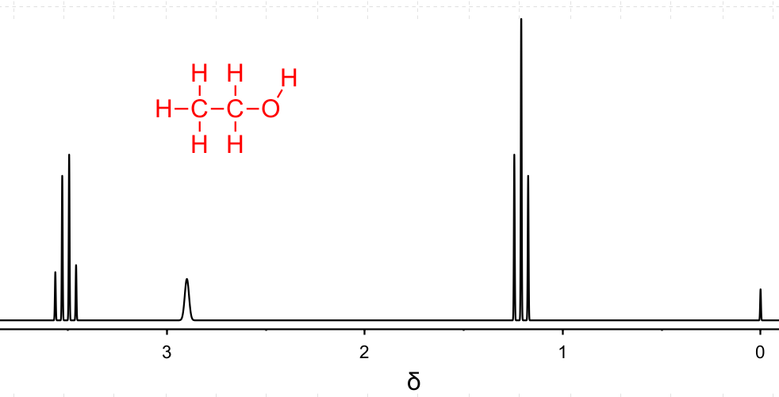
2H
1H
3H
Figure 1: ¹H NMR Spectrum of CH₃CH₂OH
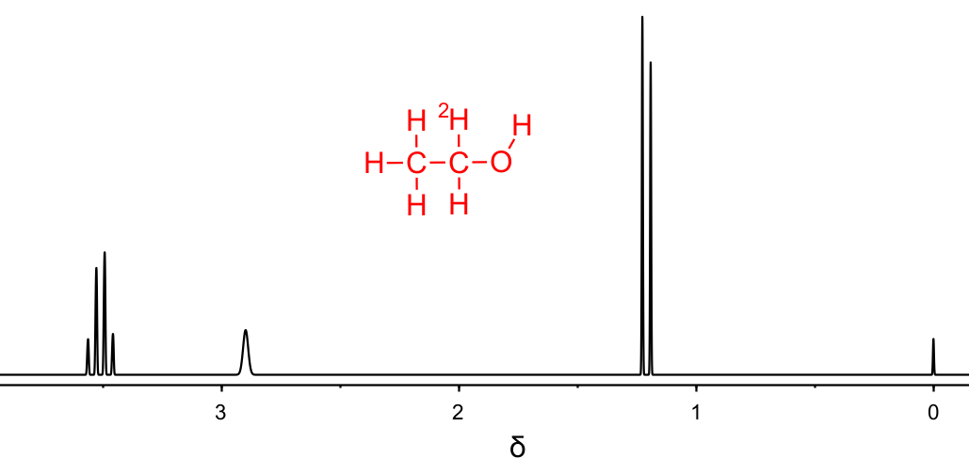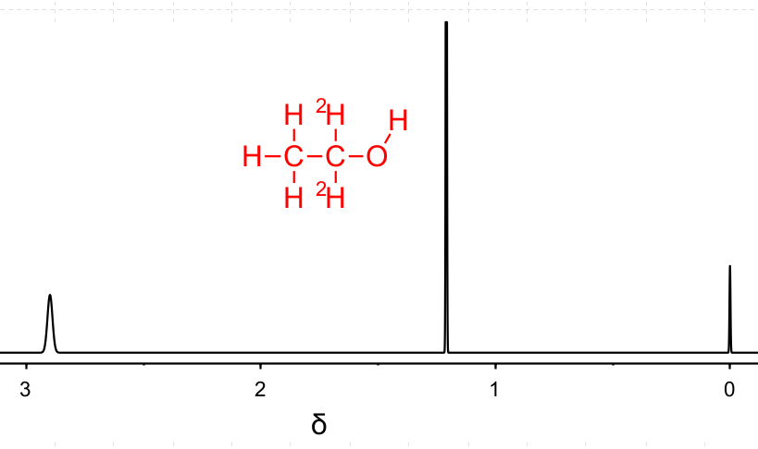
1H
3H
1H
1H
3H
Figure 2: Simulated ¹H NMR Spectrum ofCH₃CH²H₂OH Figure 3:Simulated ¹H NMR Spectrum ofCH₃C²H₂OH

Critical Thinking Questions:
- Explain the splitting patterns shown in Figure 1 of CH₃CH₂OH. Be sure to identify which protons (¹H) are associated with each chemical shift δ and why they are split that way.

- Why is there a signal at δ 3.4 ppm in Figure 2, but none found in Figure 3?

- What accounts for the difference in splitting of the peaks found at δ 1.2 ppm in Figures 1-3?

- How might isotopologues be identified via NMR?

Model 4: Mass Spectrometry of Ethanol with ¹³C Isotopes
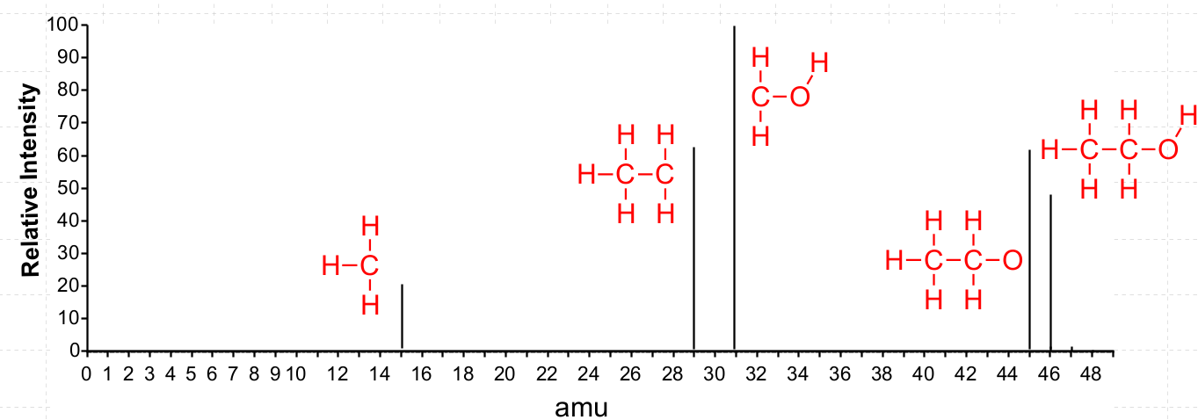
Figure 4:Simulated Mass Spectrum of CH₃CH₂OH with potential fragmentation patterns.
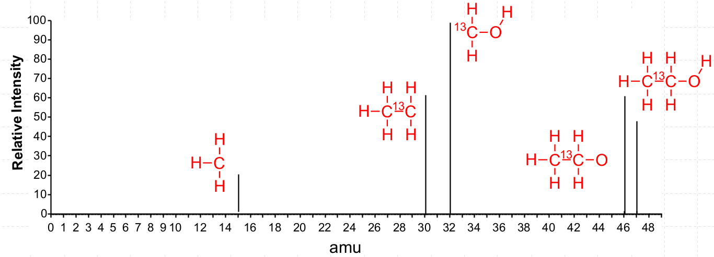
Figure 5: Simulated Mass Spectrum of CH₃¹³CH₂OH with potential fragmentation patterns.
Critical Thinking Questions:
- Explain how the shown m/z peaks in Figure 4 correspond to the structures adjacent to the peaks.

- Why do some of the peaks in Figure 5 change compared to Figure 4, but not all?

- How do the shown m/z peaks in Figure 5 indicate the ¹³C atom is on carbon 1 and not on carbon 2?

- How would the spectrum change if the molecule was ¹³CH₃CH₂OH?

- How can mass spectrometry be used to differentiate between isotopologues?

Model 5: InChI Line Notation
The International Chemical Identifier (InChI) is a standardized textual representation of chemical substances, developed by the International Union of Pure and Applied Chemistry (IUPAC). It provides a unique, machine-readable code that encapsulates the structural information of a molecule. Traditional names and graphical representations of molecules can be ambiguous and inconsistent, leading to difficulties in data sharing and retrieval. InChI addresses these challenges by offering a uniform and precise way to represent chemical structures, facilitating efficient data integration, searchability, and interoperability among different databases and software tools. This standardization is crucial for advancing research, enabling accurate communication, and ensuring reliable access to chemical information across disciplines.

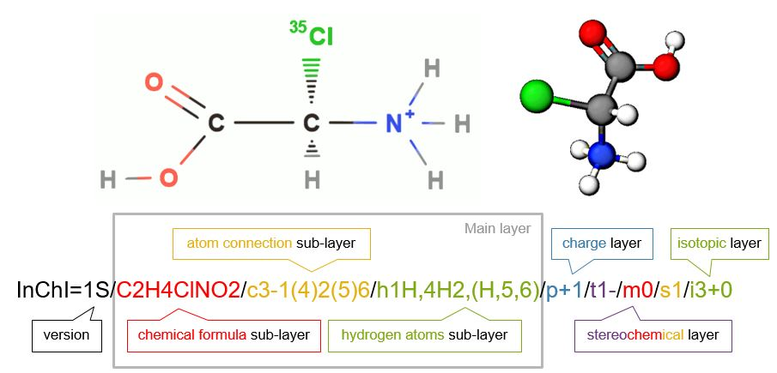
Figure 6: The main layers for a standard InChI of [(R)-carboxy(chloro)methyl]azanium, the protonated form of 2-(35Cl)chloro-R-glycine . Note each layer or sublayer is separated by a forward slash [/].
Critical Thinking Questions:
- What information is provided in the main layer of an InChI string?

- What is the overall charge in the molecule shown in Figure 6 and how is this indicated in the InChI?

- Is the molecule shown in Figure 6 chiral? If so, how is this indicated in the InChI?

- Are there any isotopes shown in the molecule? If so, how is this indicated in the InChI?

Information: The InChI Trust maintains a web demonstration of the InChI code. It is located at https://iupac-inchi.github.io/InChI-Web-Demo/ Open a web browser and go to the link.

- In the InChI Web Demo, draw ethanol and obtain the InChI.
  - What is the InChI for ethanol?

  - Which layers are included in the InChI?

  - Which layers are excluded from this InChI? Why?

- Explore the following InChI strings for isotopomers of ethanol:
Structure | InChI
 | InChI=1S/C2H6O/c1-2-3/h3H,2H2,1H3/i2D
 | InChI=1S/C2H6O/c1-2-3/h3H,2H2,1H3/i1D
 | InChI=1S/C2H6O/c1-2-3/h3H,2H2,1H3/i3D

  - What information is consistent in the InChI?

  - What part has changed in the InChI? How is the location of the deuterium atom indicated?

  - Does the numbering of the location of the deuterium atom follow standard IUPAC nomenclature numbering rules?

- Using the InChI web demo, draw the following isotopic form of ethanol:
  - What is the InChI of this molecule?

  - How is the ¹³C isotope identified in the InChI?

  - Predict the InChI for the following isotopologue of ethanol based on answers to parts a. and b.

  - Check to see if your predicted InChI is correct by drawing the molecule in the web demo.

  - How would your InChI isotope layer change if you had ¹⁴C instead of ¹³C in the previous example?

Information: To represent isotopologues, a new ambiguous isotope localization “/a” layer specification has been added to the InChI. The isotopologue layer starts with “/a” followed by an encoded description within parentheses.

- How are isotopologues and isotopomers distinquished in a standard InChI?

Homework
Consider the 13C NMR spectra of ethanol:
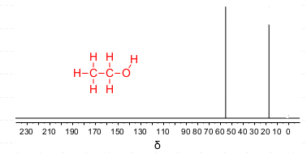
- Explain why there are two different peaks found in the spectrum and why one is more downfield than the other.
- Is the spectrum the result of isotopomers or isotopologues? Explain.
- What is the relationship between ¹³CH₃CH₂OH and ¹³CH₃¹³CH₂OH?
- Using the InChI Web Demo, generate InChI for the three ¹³C isotopologues of ethanol.

